Use Case 1: Add money to the balance

Step 1. User opens the app.

Step 2. The app shows the UI.

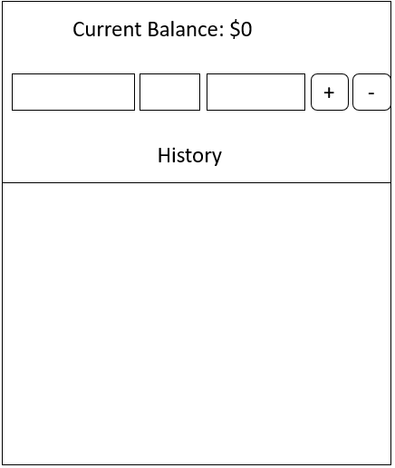

Step 3. User enters the content and click “+” button.

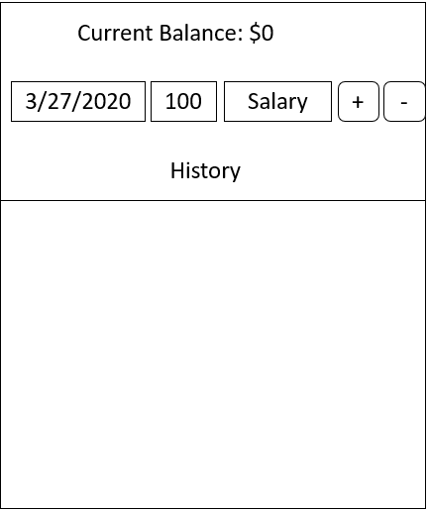

Step 4. The app updates the current balance and shows the transaction in the history.

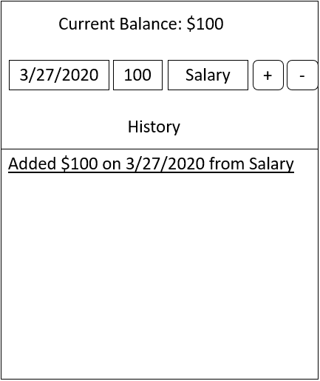

Use Case 2: Spend money from the account

Step 1. User opens the app.

Step 2. The app shows the UI.



Step 3. User enters the content and click “-” button.

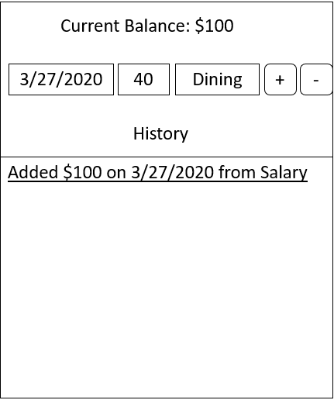

Step 4. The app updates the current balance and shows the transaction in the history.

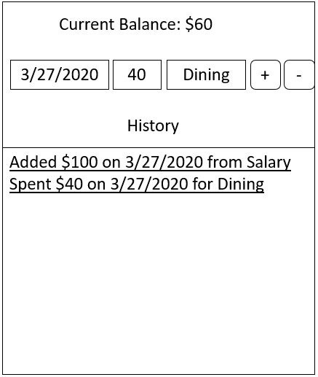

Use Case 2: Check balance and history

Step 1. User opens the app.

Step 2. The app shows the current balance and history from last time

